DBMS Lab Assignment 1
Neeti Kurulkar
Draw E-R Diagram for ‘Bank Management System’ and also draw relational tables and normalize relational data model.

Diagrams:
- E-R Diagram for Bank Management System

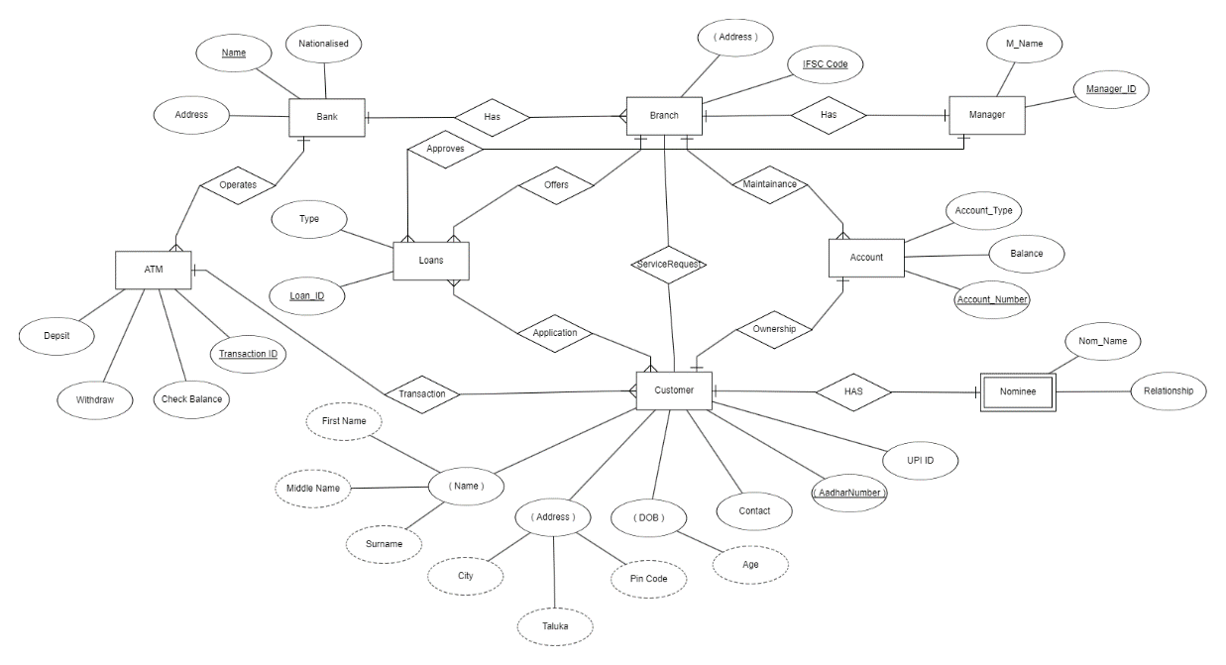

- Relational Data Model

